6 simple ways to stress free Dentistry.

horizontal line

Everyone needs dental care to protect their smiles and their general health, but for some people, this is easier said than done. One of the most common reasons people avoid visiting a dentist is the fear of discomfort and a painful experience.

In the past, this may have been an issue, especially if you had extensive dental work to get done. However, technology has improved dental care over the past several decades. With recent advancement in technology and dentistry, you can now experience painless dentistry at many of the best dental clinics in Mumbai and we’re proud to say The Dental Bond is one of them.

Overcome your dental fear or dental anxiety with these simple steps.

1. **Talk to your dentist or dental team**

Communication is the key to understand and make people understand you. Talking to your dentist or the dental team about your specific dental fears or any negative past dental experience can make them understand you and your fears. It will help the dentist and the dental team to provide you with certain care and techniques to give you a positive dental experience.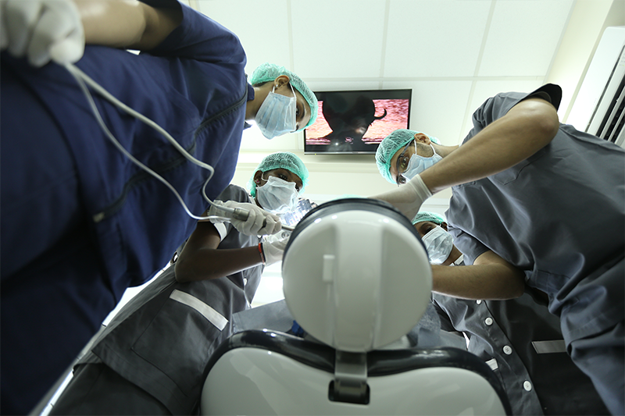

1. **Distract your mind**

Music, videos, podcasts can be very effective in distracting your mind. Relaxing music helps your mind feel calm. Watching Funny videos or cartoons helps too.

1. **Pain free procedures**

Not all dental procedures are painful. With recent advancement in dentistry and technology, many dental procedures are now painless and can give you anxiety free experience with dental care.

1. **Techniques that can help**

There are many new techniques in dentistry that can help you sedate and have painless dental experience. To know more about sedation [painless dentistry](https://thedentalbond.com/blog/painless-dentistry/). These techniques are nitrous oxide inhalation sedation, oral sedation and IV sedation. Most routinely used is inhalation sedation for both adults and children and The Dental Bond is one of the dental clinics in Mumbai to have nitrous oxide sedation technology. Ask your dentist or the dental team about techniques that can help you have an anxiety free experience.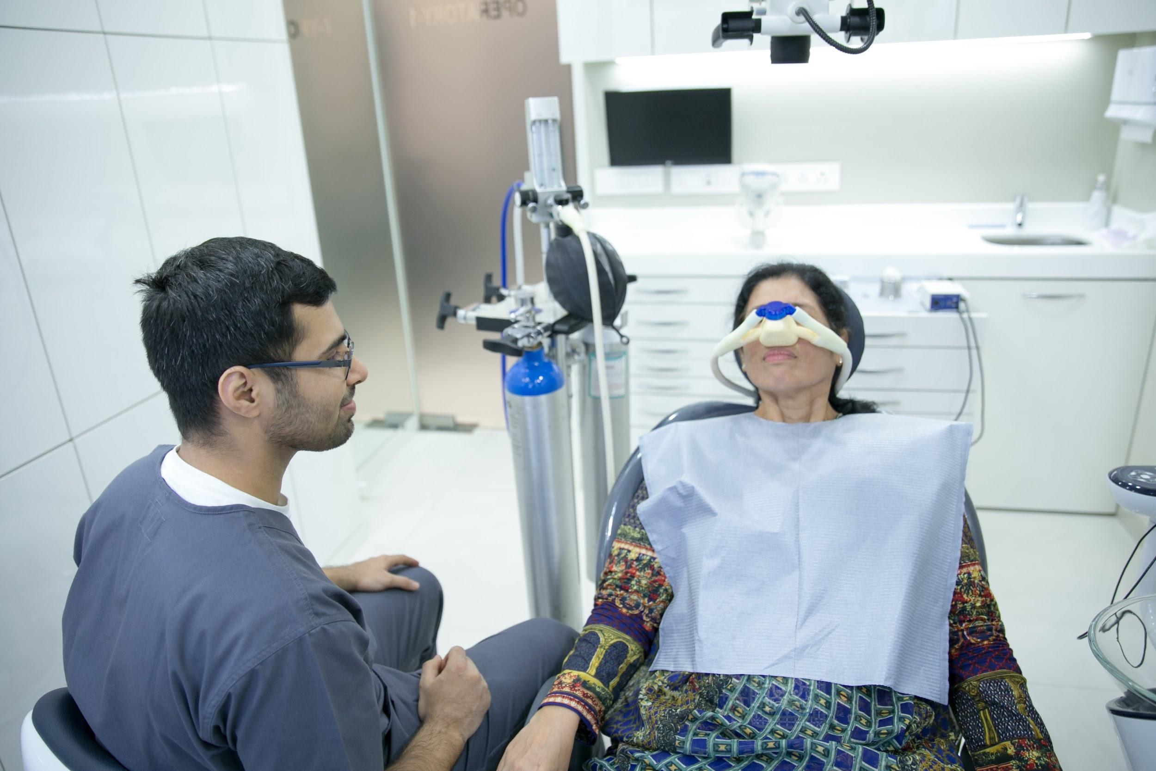

1. **Hand gestures** 

Establish certain hand signals amongst you and your dentist to communicate your discomfort. Hand signs during the dental procedure can help your dentist understand if you have any discomfort or need a break. It's a great way to communicate during the dental procedure.

1. **Deep breathing** 

They say, “Take a deep breath, it calms the mind”. Deep breathing during unpleasant moments can be soothing and help you distract your mind .

At The Dental Bond, one of the best dentists in Mumbai is equipped with the latest advanced technology, expert staff, and ultimate dental experience to make your next trip to the dentist painless and also a pleasure.